CE-791

SeyedMojtaba Noghabaei

North Carolina State University

CE-791

Pipe Overflow Prediction Model in Stormwater Networks and Visualization Using Mixed Reality

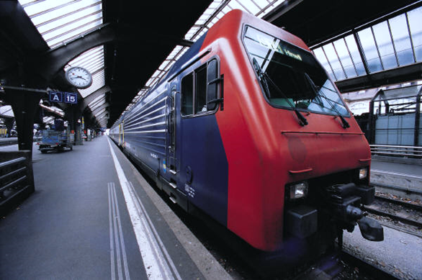

# Abstract

**Objective**:   
**Methods**:   
**Results**:   
**Conclusion**:

Keywords: Mixed Reality; Smart Cities; Digital Twin Model; Artificial Neural Network (ANN); Overflows prediction model

# 1. Introduction

// **[the situation]**

**One of the new and growing technologies in the U.S. and all over the world is smart city technologies. The smart cities technologies can save over $5 trillion for enterprises, governments, and citizens annually over the world (**<http://www.information-age.com/smart-cities-lead-cost-savings-5-trillion-123469863/>**). For example there is a $14 billion saving opportunity for enterprises in areas like more efficient transportation options such as drones, robots or driverless cars and trucks and there is a $5 billion annual saving opportunity for governments using street lighting and smart building technologies. Using smart street lights it is expected to reduce repair and maintenance costs by 30 percent. It is possible to utilize smart city technologies in new areas in order to achieve more savings.**

**// [the problem]**

Many researcher tried to utilize smart cities technologies to achieve more savings in different areas like smart transportation, smart infrastructure, smart Disaster Management System (DMS), and smart visualization. Two areas that still need more developments are smart DMS and smart visualization. Many researchers tried to develop emergency response system in order to reduce costs during a disaster. (A smart disaster management system for future cities), but still there is a big gap between other sections of smart cities and smart DMS. Furthermore, smart visualization technologies can help utility managers to reduce costs as well. (IMMERSIVE DATA VISUALIZATION FOR SMART CITIES))

// overflow problems

Overflow in wastewater and storm water networks is one of the old problems of metropolitans with old networks. Especially in cities like Chicago because of old combined wastewater networks. Detection of these overflows and the reasons behind might be very helpful in post and pre disaster responses.

// smart DMS

// smart visualization

// **[the solution]**

The researchers in this paper tried

# 2. Literature Review

## 2.1 Pipe overflow problems

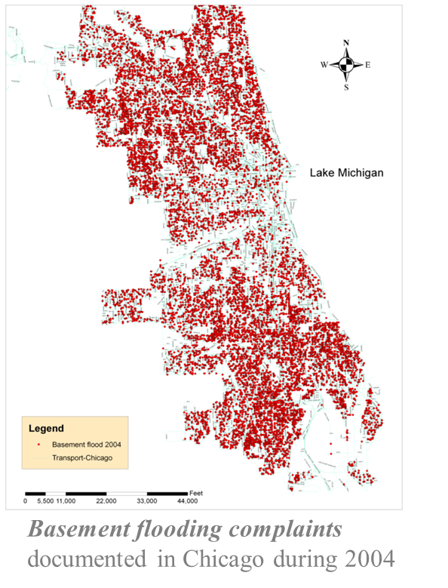

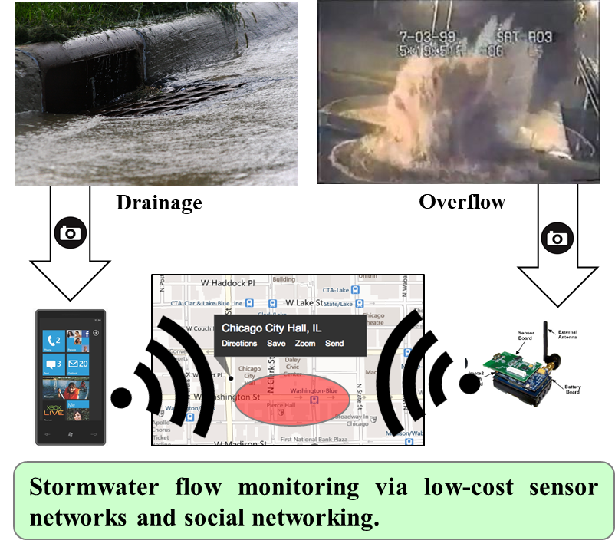

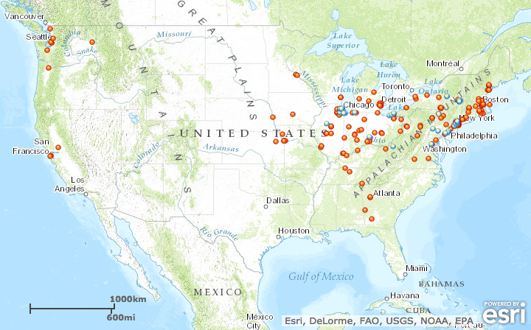

## 2.2 Data visualization challenges

VR is a relatively new concept not only in the construction industry but all the other industries as well. There has been a lot of research about linking various industry specifics components with the VR. Research, however, on the applications of VR have been relatively limited and still in growing stages. The purpose of this study is to develop a framework for estimating construction cost using VR model. This is a fairly new concept and hence no peer reviewed paper has been published, linking VR to cost estimation, yet. However, there have been numerous researches on the concept of VR that provides or points at the need for research in this direction. Linking cost estimation to improvements in information technology has proved beneficial for the construction industry and the estimators. The results of this paper should also provide estimators with a VR framework and get automated cost variation upon changing material for the construction.

(Sampaio and Martins 2014)focused on the application of VR in the field of education. They use VR to give a better insight and a thorough understanding to students about the two commonly used methods of bridge construction of the incremental launching and the cantilever method. By using the VR, the researchers were able to visualize the construction process evolution and monitoring the planned construction sequence. Their field of application proves to be more appropriate since it is hard to get the same amount of detail and knowledge at the construction sites due to safety reasons. Although this method does clearly delivers the amount of knowledge and 3D visualization, this is limited to bridge construction only. There is no interaction in the 3D environment and lacks the modifications to be done, if any.

(Q. H. Wang, Li, and Gong 2006)studied about the link between CAD and VR assembly. The information provided and the external integration technique used by the authors provides an outline for the 3D models to be extracted in the VR environment for the project. Also, the authors designed the assembly in such a way that the VR model was updated and created automatically if there were any changes made to the CAD file. The idea proposed in this paper was that of a combinator, a script which converts the Autodesk library to a format that is recognized by the VR interface, which linked the datasets of one file type to the other. The combinator proved to be immensely successful in linking both interfaces together. The combinator however does not allow for a return loop meaning that there can be no changes that can be made in the VR model once it was imported from CAD. If any changes had to be made, the user will have to go back to the CAD model and make the desired changes.

(Hilfert and König 2016)investigated on building a low cost VR environment. They paid prime importance to immersion in the VR environment and built an interactive VR environment using the Oculus Rift and the leap motion hand tracking device. They have to overcome the inability of shutter glass (head mounted 3D visualization device) and VR walls to provide a larger field of view. In the paper, the researchers also present a plug-in which links the BIM to the game engine they used which is Unreal Engine 4. Having those two linked together, they use the oculus rift and leap motion to provide an interactive VR environment. The field of view is very large and immersive and is definitely able to get a large immersive level from a Head Mounted Device (HMD). The simulations that were run proved to be pretty realistic and there is a huge scope for other simulations in future. Although it is a relatively lower cost environment but it still is pretty expensive if it was to be used as a training device to train multiple crew members or teams.

(Grabowski and Jankowski 2015)suggested VR as a solution for improvement of occupational health and safety of coal mine workers. They did a pilot training with 21 people from the mining industries which were trained professionals in the industry and some training supervisors so they definitely knew how the training should be. They also compared results of using different motion capture systems, HMD’s with different field of views and different training scenarios. They also used the HMD’s along with joysticks as input methods. The study confirmed that VR can be chosen as a very effective platform and substitute to onsite training. Using VR in training coal miners would prevent the trainees from exposure to all the dangers and risks which might exist on the mining site.

(Nikolic, Jaruhar, and Messner 2009)portrayed the first and second era advancement of a Virtual Construction Simulator. It is a tool which proved to be reliable and effective solution to the challenges faced by students in visualizing 3D structures. The tool is based upon the concept of VR. It allows students to visualize and review various designs through VR environment interaction. The efficiency and usefulness of the tool was assessed by surveys, group interviews and in class exercises in a construction management class. The results showed that subjects had far better understanding of concepts when using VR interface.

The commercial application of VR was studied in (Greenwood et al. 2008). The results are obtained by conducting a study on strategically selected four countries that are China, Sweden, UK, and US. Purpose of the study is to find out various barriers that VR faces in terms of application in various countries. It also emphasized on the fact that VR might be expensive in terms of usage by various countries and small contractors but studies are underway to come up with cost effective graphic cards for a widespread application of the concept of VR.

//previous paper

Asdasd(“Improved Stakeholder Communication and Visualizations: Real-Time Interaction and Cost Estimation within Immersive Virtual Environments” 2016)

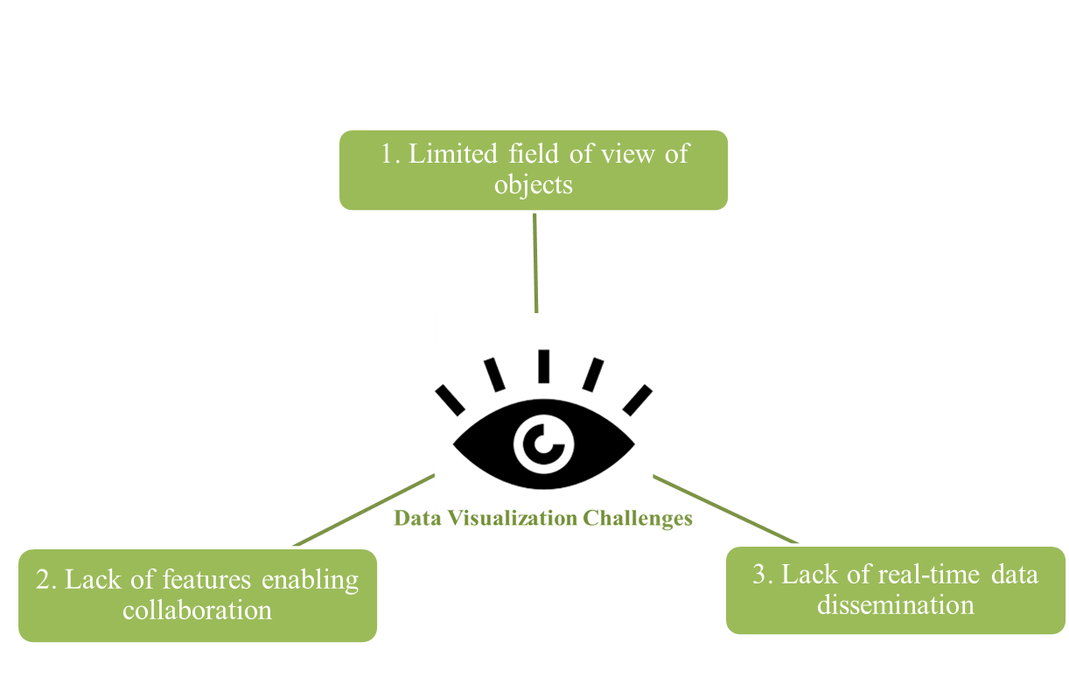

## 2.3 MR in civil and smart cities industry and other industries

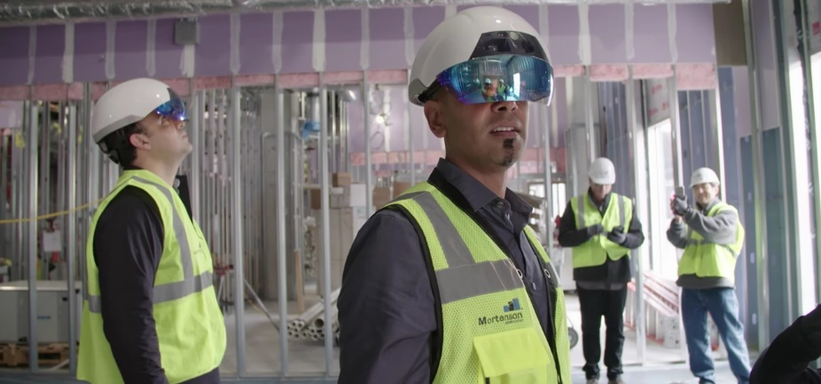

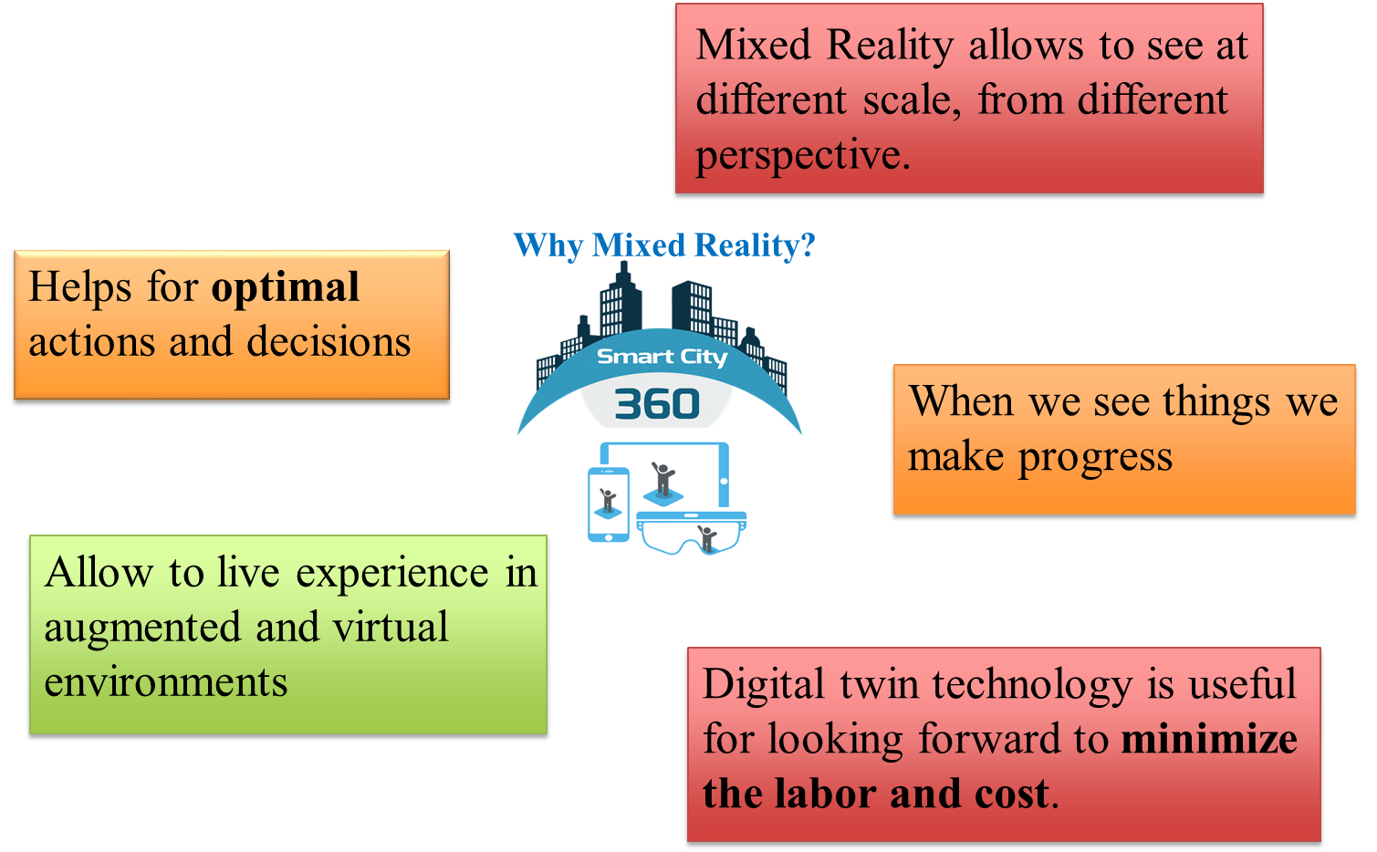

# 3. Research Objectives

The main objectives of this study is to predict pipe overflow problems in Stormwater networks and create a MR digital twin in order to improve.

1. Create a platform to predict overflows in order to help utility managers before disasters
2. Create a digital twin for the Stormwater network and enable utility managers for better decision making using Mixed Reality technology

# 4. Method

For achieving the objectives the researchers used the following approach. At the beginning the researchers gathered the overflow data from Storm Water Management Models (SWMM) for the city of Raleigh. After that the researchers created an artificial neural network model in order to predict overflow positions based on the SWMM data. Finally, the researchers visualized the overflow problems in a MR environment in order to achieve better visualization and collaboration for utility managers. Gather data from previous overflows or SWMM

1. Generate data from SWMM
2. Create models for predicting overflows
3. Visualize in a twin MR model

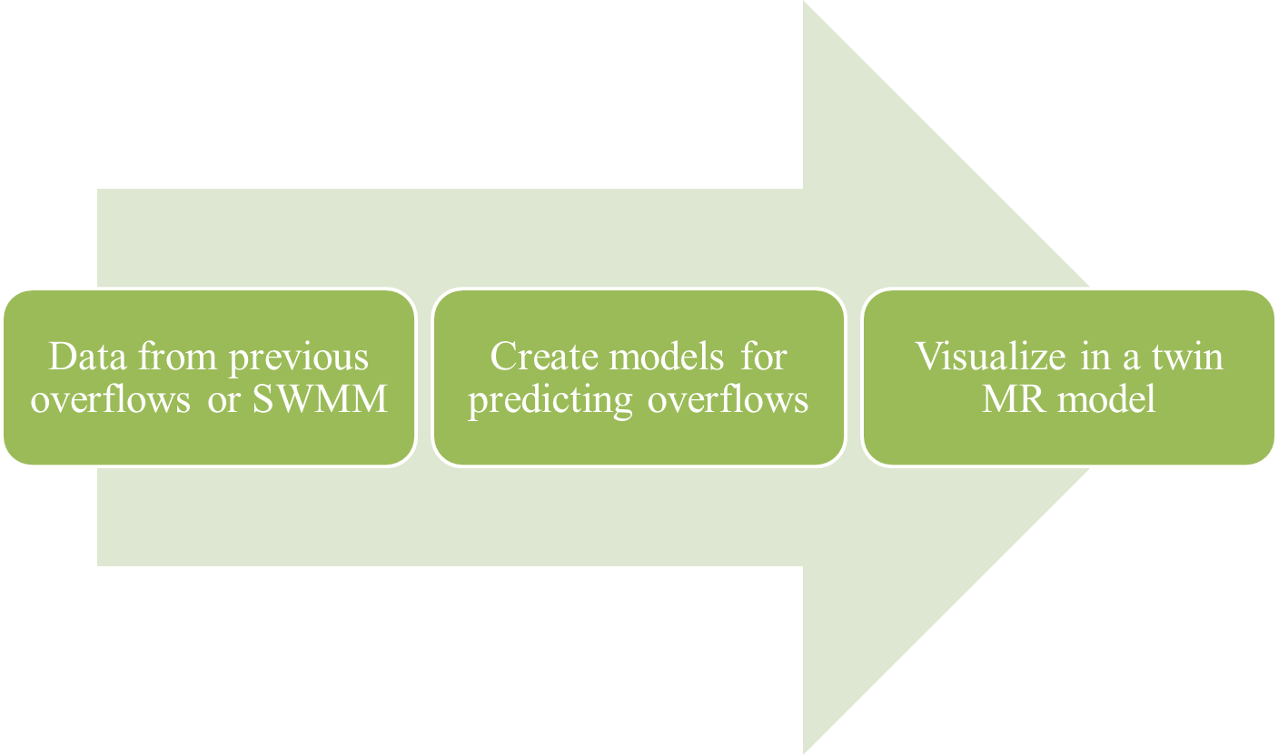

// System architecture

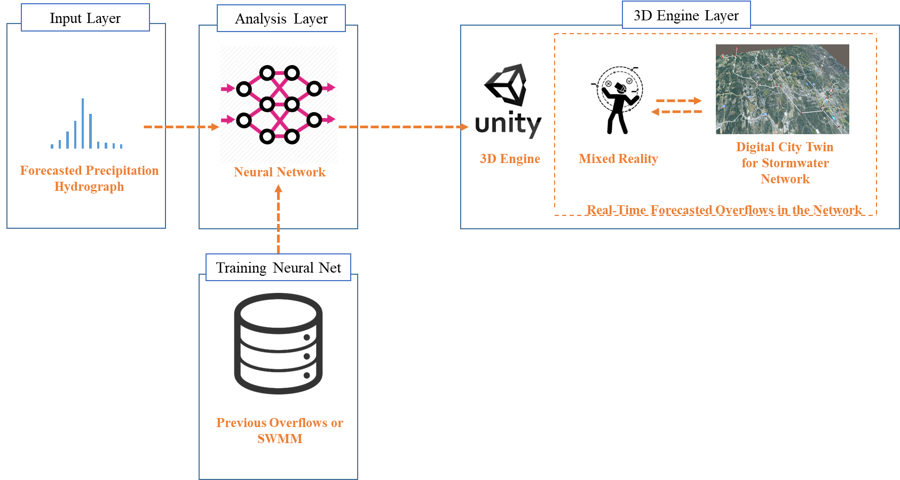

## 4.1 Pipe overflow modeling

For the first step two online surveys were designed to target a range of construction related engineers, designers, researchers, managers, and owners. The surveys contains of 6 different categories:

1. Personal information
2. Company related information
3. BIM knowledge
4. AR/VR from different aspects
5. Future of AR/VR
6. Visions for savings through AR/VR

The first round of survey consists of 94 participants and in the second round, 64 respondent participated in the survey and totally 157 participated in the both surveys. The researchers conducted the first round of survey in 2016 and the second round in 2017.

### 4.1.1 Data from previous overflows or SWMM

* Run SWMM for 150 of different precipitations and find pipes or junctions with overflow problems
* 5 minute sampling hydrographs
* All data is from city of Raleigh

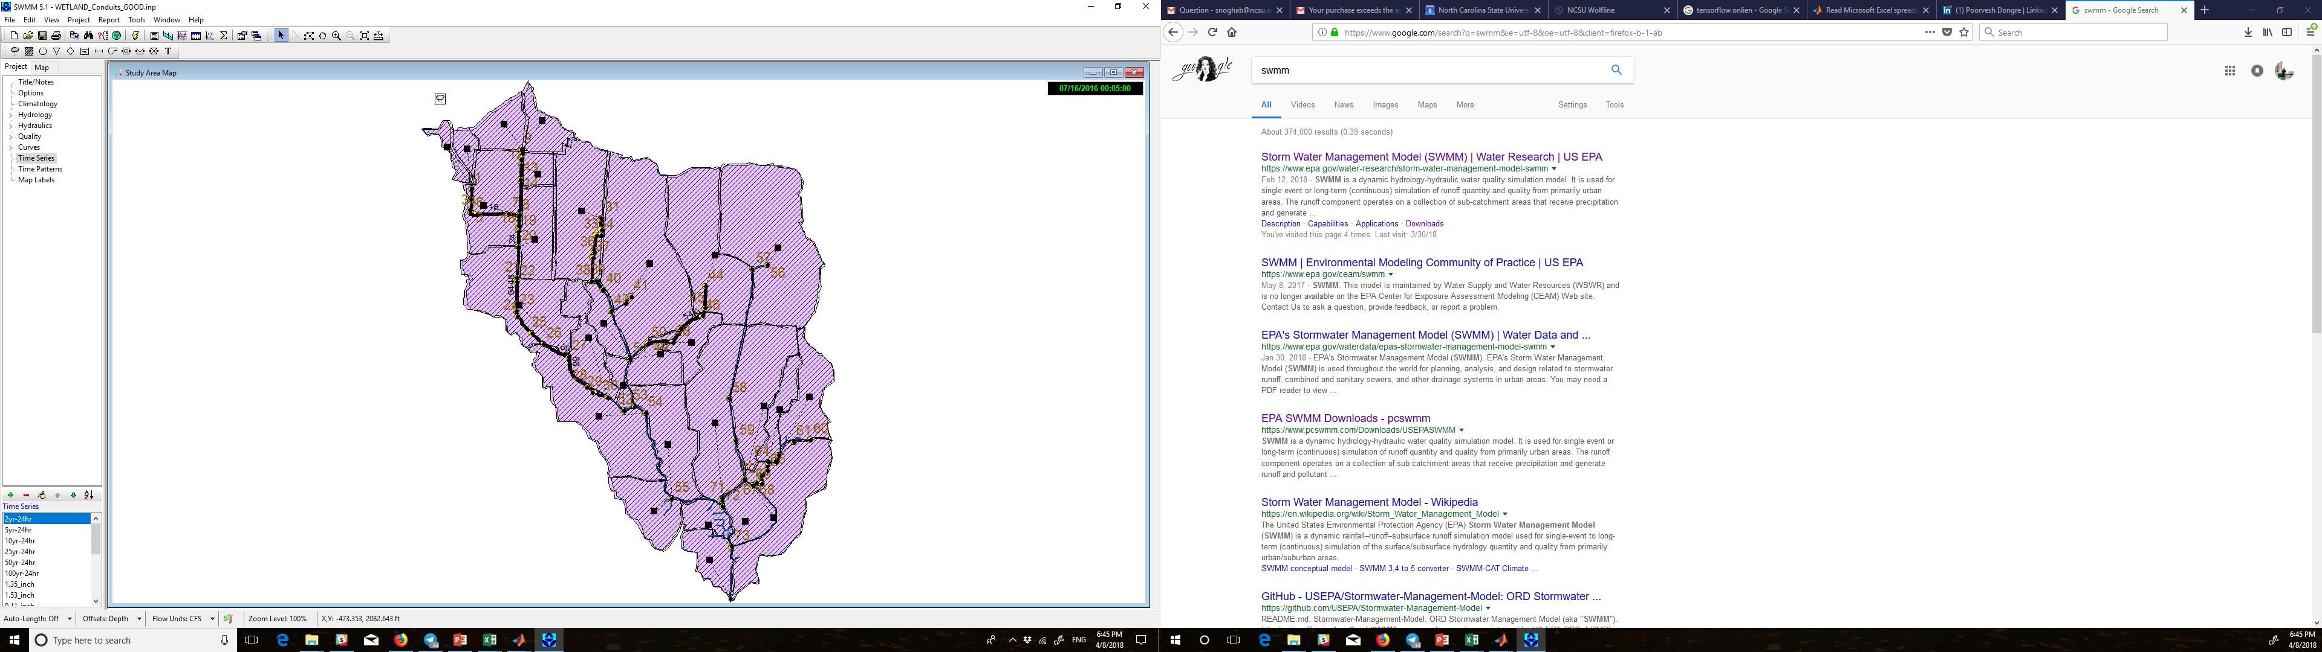

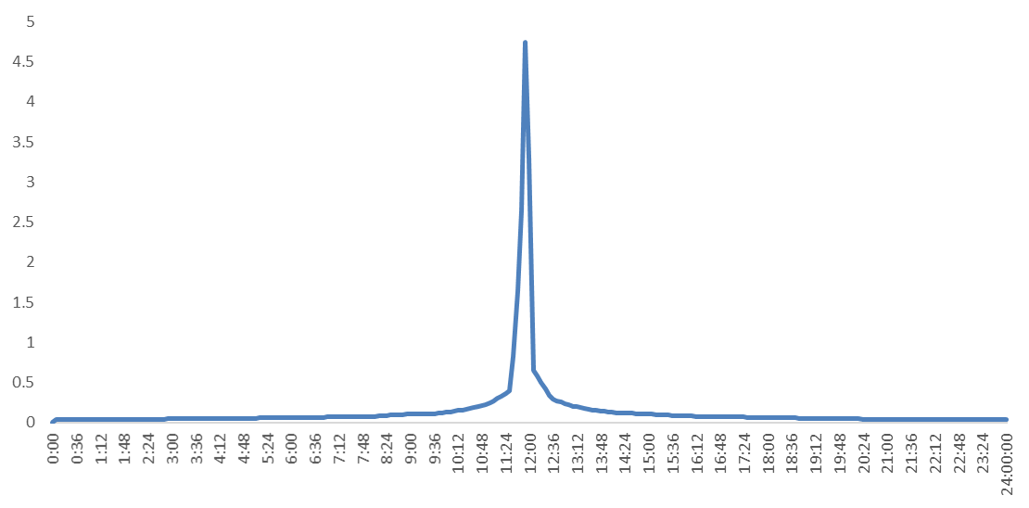

* Precipitation hydrograph (5 min sampling)
* Precipitations with high peak

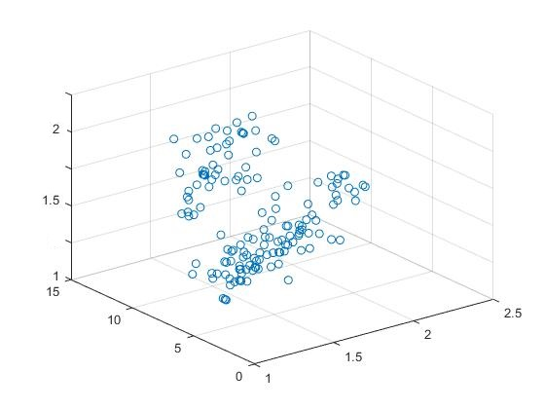

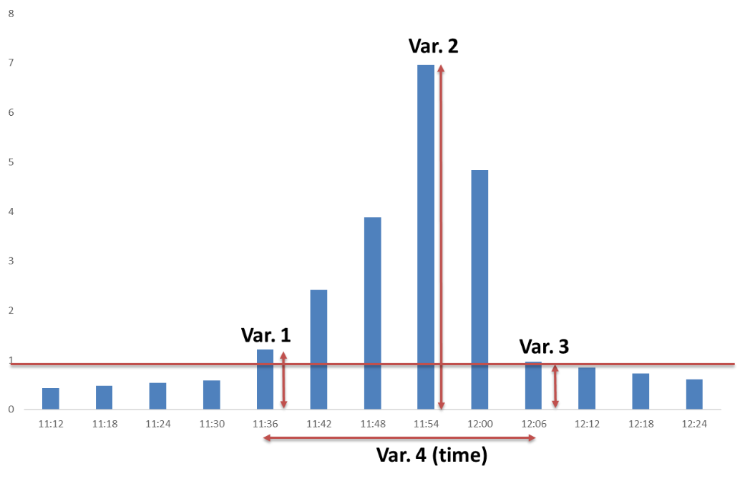

### 4.1.2 Develop neural network models for overflows problems

* Neural net fitting
* 4 inputs for each hydrograph
* 3 hidden layers
* 73 outputs for each junction in network(1 or 0)

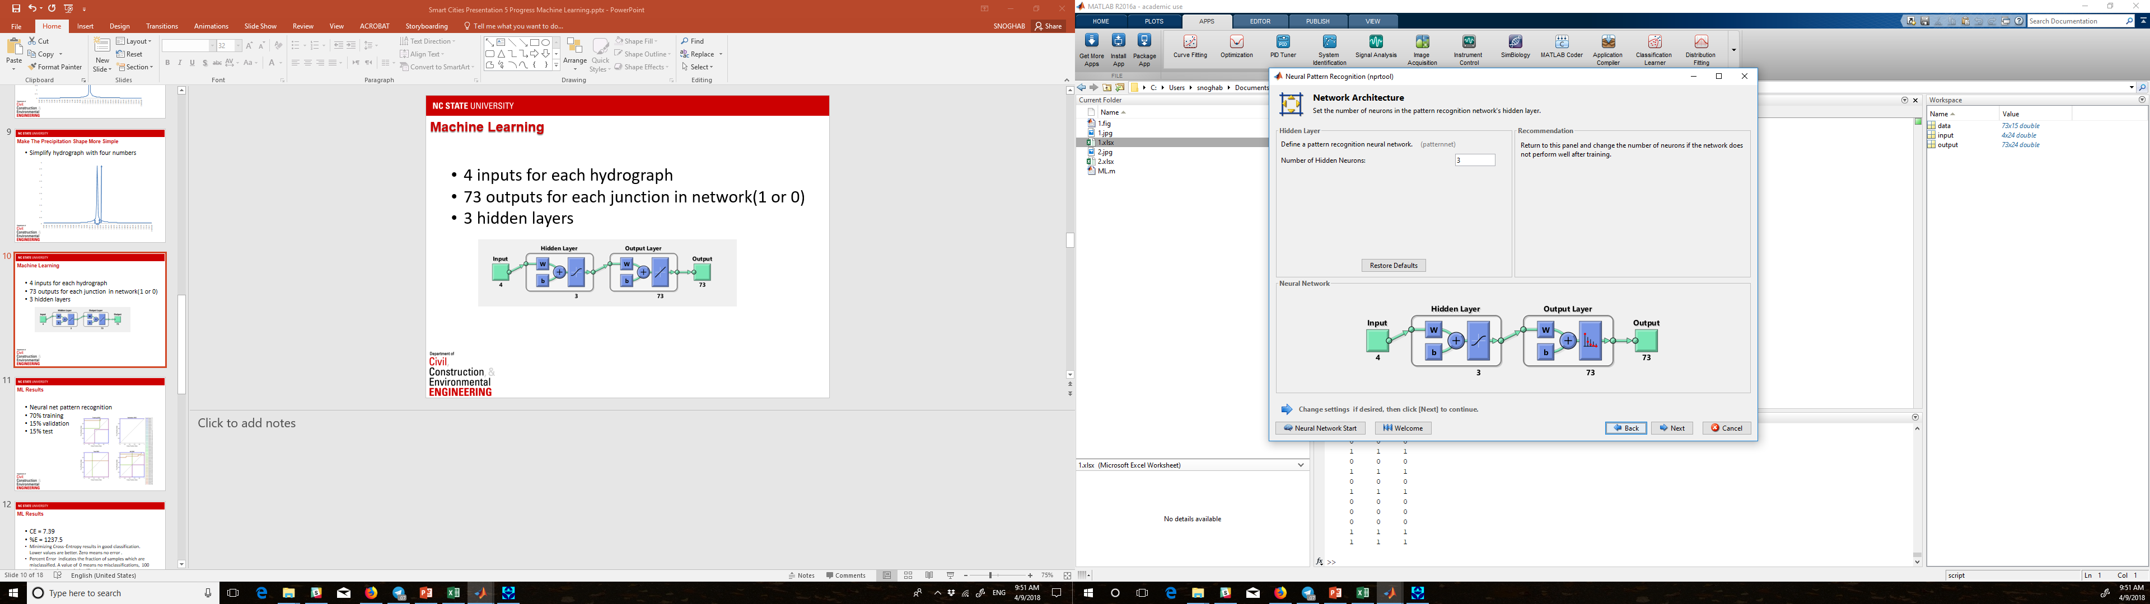

* 70% training
* 15% validation
* 15% test

### 4.1.4 Data analysis

// investigate the main 3 factors

As a digest of aforementioned hypotheses. The main limitations of VR/AR utilization in construction industry is lack of budget, lack of understanding of upper management, and lack of knowledge of design teams. Finding a solution for these limitation can simply improve VR utilization and customer satisfaction rate.

## 4.2 MR digital twin model

//About the opportunities from surveys

It is possible to use VR models for different purposes in construction like

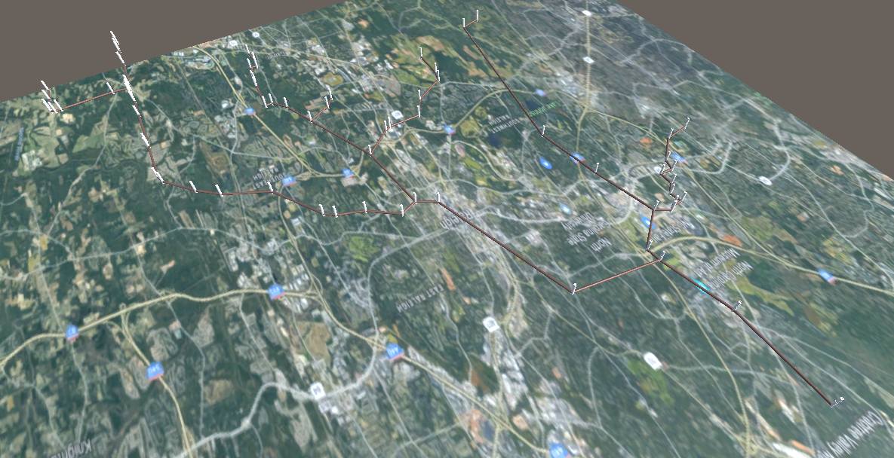

### 4.2.1 Procedure

// Flow

# 5. Results and Validations

* Real-time over flow prediction platform
* Test a totally new sample with just one misclassification
* The results of this study shows how we can use data collected by sensors to improve management and predict overflows.

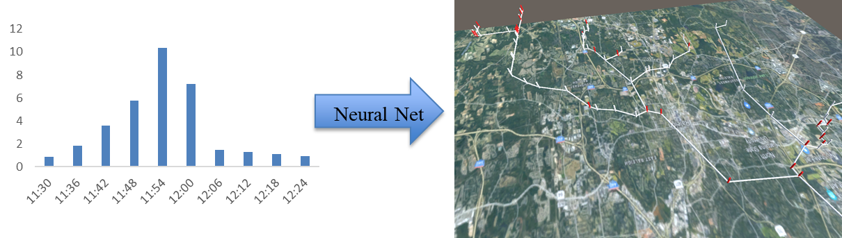

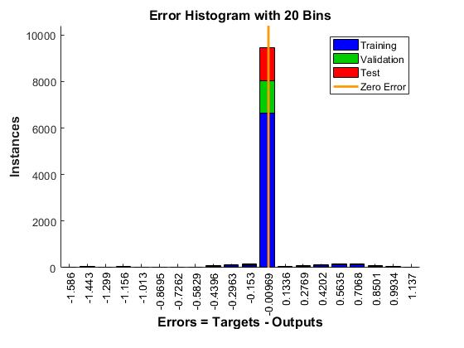

# 6. Limitations and Future works

## 6.1 Limitations

* It is a predicted model and cannot detect issues caused by extraordinary events
* How we can use our resource in an optimal way?

## 6.2 Future works

// Using Mixed Reality instead of Virtual Reality

It is possible to bring more advanced technologies like Mixed Reality into the AEC industry. Mixed Reality can give better understanding to clients before building repair or maintenance. For example clients can walk inside the existing building while Mixed Reality headset understand the location so clients can apply changes to the design by understanding difference in cost and shape in real time.

// Adding furniture and arch. Elements

The main focus of this research was not about architectural elements like furniture.

Virtual Reality is a new technology and there are several ways to implement this technology into the construction industry. There are several limitations for this study as follows:

**//Multiplayer VR**

By connecting several VR headsets in a multi user simulation, users can be in a same environment and see the changes in the same

**//streaming data from different vendors**

Instead of using RS Means it is possible to use real vendors’ prices for the cost estimation model and this feature gives the users a real local prices.

**//Designing the entire building in immersive environment**

VR gives a better understanding about the models so it can be used as a base platform for designing.

# 7. Conclusion

* Efficient stormwater management
* Rapid and ahead of time response in emergencies
* Efficient disaster management
* We can use this approach in other areas smart cities like traffic, water network, and natural gas network.
* The problem was predict overflow and visualize it in a better way
* We used different types of neural networks and tested them and reported the best one
* Finally we were able to train a neural network model using our data and predict overflow and visualize it in a digital twin model of network

# 8. References